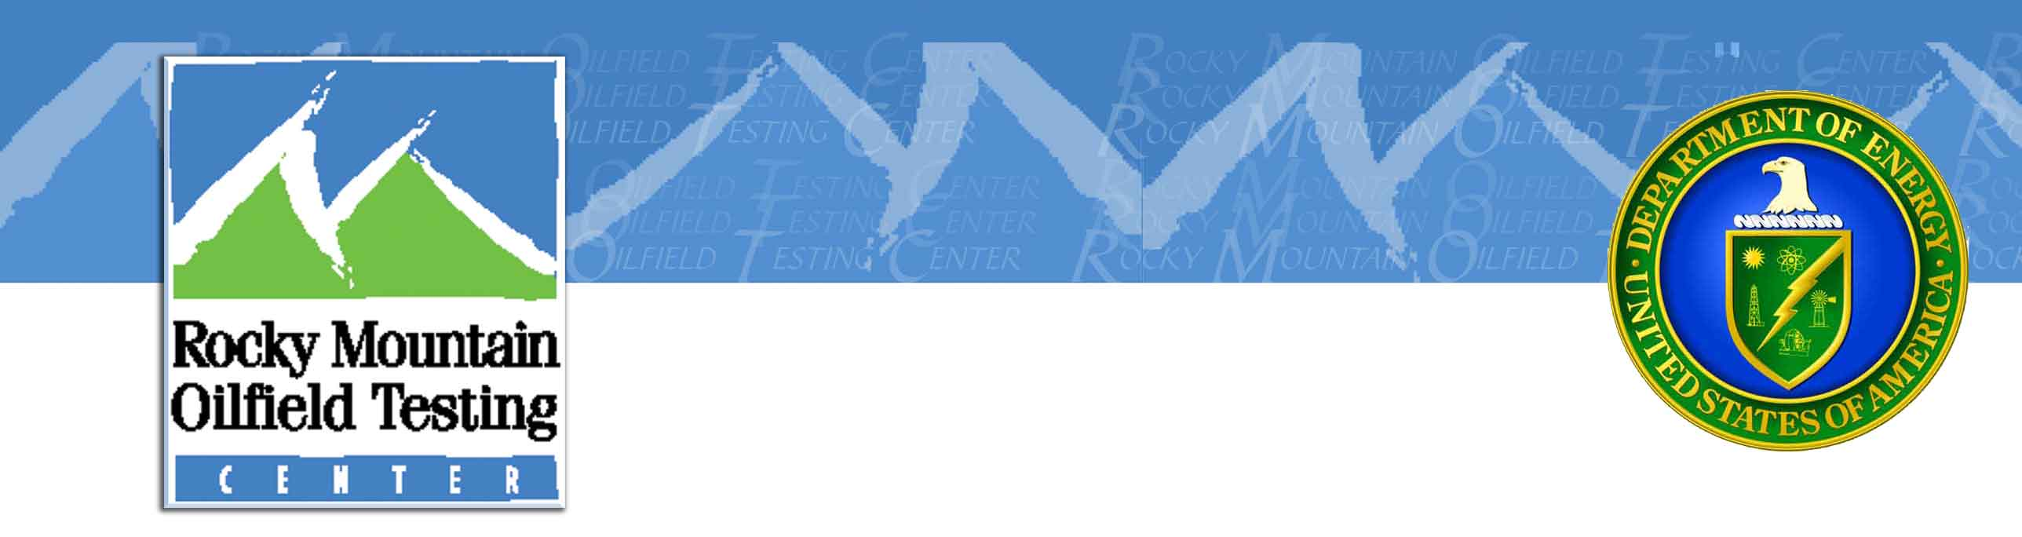

The three conditions for use of the free non-proprietary data are as follows:

1. The data is to be used for one or more of the following:
a. Scientific research
b. Testing and demonstrating software
c. Training end-users
d. As an exploration/production analog

2. Your name and other contact information is provided so RMOTC can keep a record of who has the data and how it is being used.

3. RMOTC and the DOE in any presentation or publication are acknowledged in any presentation or publication.

Terms of Use:

The data contained on this CD is non-proprietary. Its intended use is for scientific research, testing and demonstrating software, training end-users, and as an exploration/production analog.

If you use this data in any presentation or publication, acknowledge RMOTC and the U.S. Department of Energy as the data source.

Connie Wallace
RMOTC Business Development Manager
Rocky Mountain Oilfield Testing Center
907 North Poplar, Suite 150
Casper, WY 82601

Direct: 307-233-4800
Toll Free: 888-599-2200
Email: connie.wallace@rmotc.doe.gov

